**Landing Page**

Background #EDF4FA

Text (main) #212121

Paragraph #4F4F4F

Logo

Content

**Welcome to the (main text)**

**Mental Stress & Workload Management Dashboard (main text)**

This system is designed to support your mental well-being and productivity. It helps employees and organizations manage workload stress through simple tools for logging, feedback, and expert support.

### What You Can Do:

Track Your Stress Log Daily Workload |

Understand stress score |Enter daily tasks |

Chat with AI Assistant| 👩‍⚕️ Contact Consultant |

Get tips & support | View & message experts|

### Get Started Now

**Choose your role and begin your journey toward better mental wellness and workload balance.**

**[Sign In]  [Sign Up]**

**Signup Page**

### Common Fields (All Users)

| Field | Type | Validation | Notes |
| --- | --- | --- | --- |
| First Name * | Text | Required |  |
| Last Name * | Text | Required |  |
| Gender * | Radio | Required | Male / Female / Other |
| NIC Number * | Text | Validate format (Sri Lanka NIC) |  |
| Birthday * | Date | Required |  |
| Contact Number | Number | Srilankan standard |  |
| Job Role * | Dropdown | Required | Employee, Supervisor, HR Manager, Consultant |

### Employee-Only Fields

| Field | Type | Notes |
| --- | --- | --- |
| Employee ID * | Text | Unique |
| Department * | Text |  |
| Team * | Text |  |
| Address * | Text |  |
| Supervisor Name | Text | Connect to supervisor if linked later |

### HR Manager-Only Fields

| Field | Type | Note |
| --- | --- | --- |
| Employee ID * | Text | Unique |

### Supervisor-Only Fields

| Field | Type | Note |
| --- | --- | --- |
| Employee ID * | Text | Unique |
| Department * | Text |  |
| Team * | Text |  |

### Consultant-Only Fields

| Field | Type | Note |
| --- | --- | --- |
| Registration Number * | Text | Unique |
| Hospital * | Text |  |

### Login Fields (All Roles)

| Field | Type | Validation |
| --- | --- | --- |
| Username * | Email | Valid email format |
| Password * | Text | Min 8 characters |

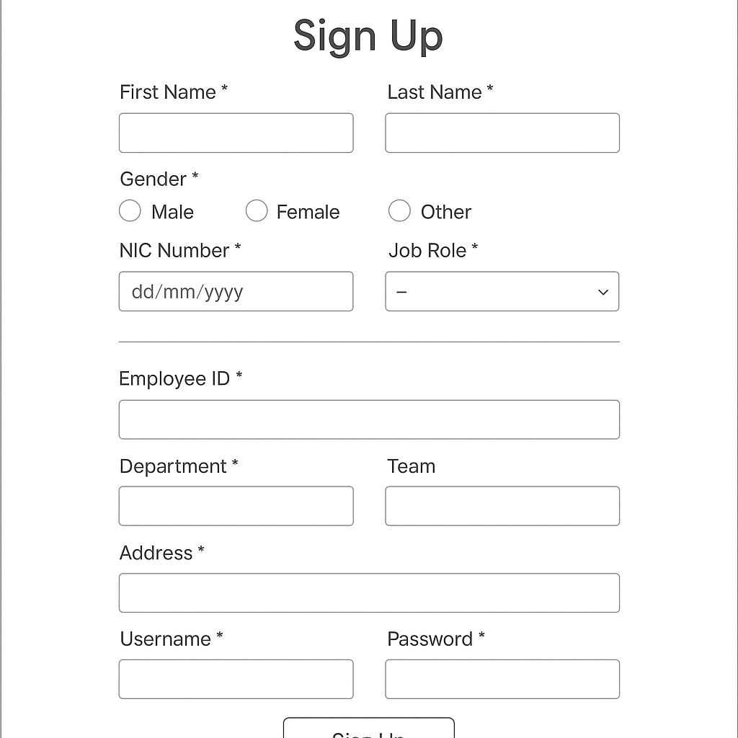

**Sign in**

**User name**

**Password**

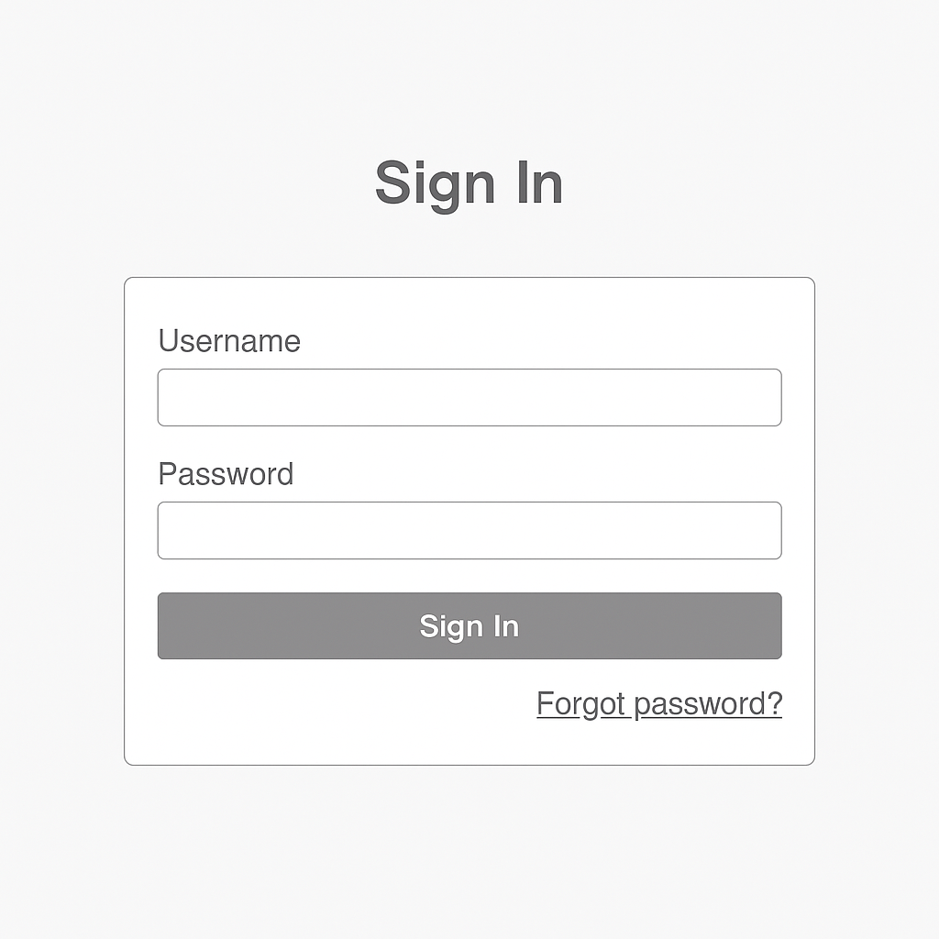

Colors for both signup and sign in

Background #EDF4FA Light blue-gray for calm atmosphere

Form Card #FFFFFF Clean white card to focus user attention